

**CZ2007 Lab 5 SQL Queries**

**Group 2**

**Date:** 2th November 2020

**TABLES**

SHOPS(Shops_name)

USERS(Users_ID, Users_name)

EMPLOYEES(Employees_ID, Employees_name, Salary)

ORDERS(Orders_ID, Users_ID, Shipping-address)

PRODUCTS(Products_name, Maker, Category)

PRODUCTS-IN-ORDER(Shops_name, Products_name, Orders_ID, Status, Delivery-date, PIO_quantity, PIO_price)

PRODUCTS-IN-SHOPS(Shops_name, Products_name, PIS_price, PIS_quantity)

PRICE-HISTORY(Shops_name, Products_name, PH_price, Start-date, End-date)

COMPLAINTS-ON-ORDERS(Complaints_ID, Orders_ID, Products_name)

COMPLAINTS-ON-SHOPS(Complaints_ID, Shops_name)

COMPLAINTS( Complaints_ID, Employee_ID, Text, Status,Filed-date-time,Users_ID)

IN(Orders_ID, Products_name, Date-time)

IN(Shops_name, Products_name, Price-variation, Start-date, End-date)

FEEDBACK(Users_ID, Shops_name, Products_name, Orders_ID, Rating, Comment, Date-time)

HANDLED(Employees_ID, Complaints_ID, Handled-date-time)

SHOPS table:

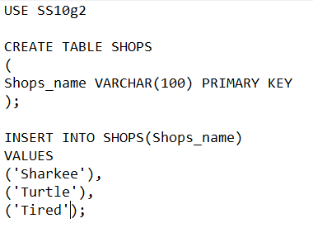

USERS table

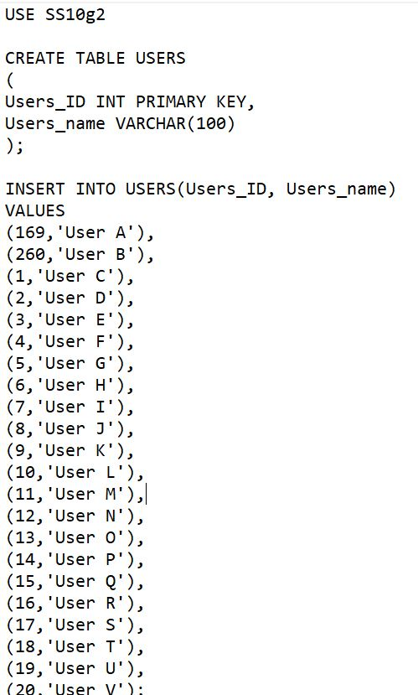

EMPLOYEE table:

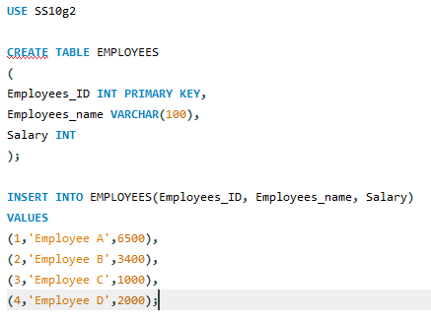

ORDERS table:

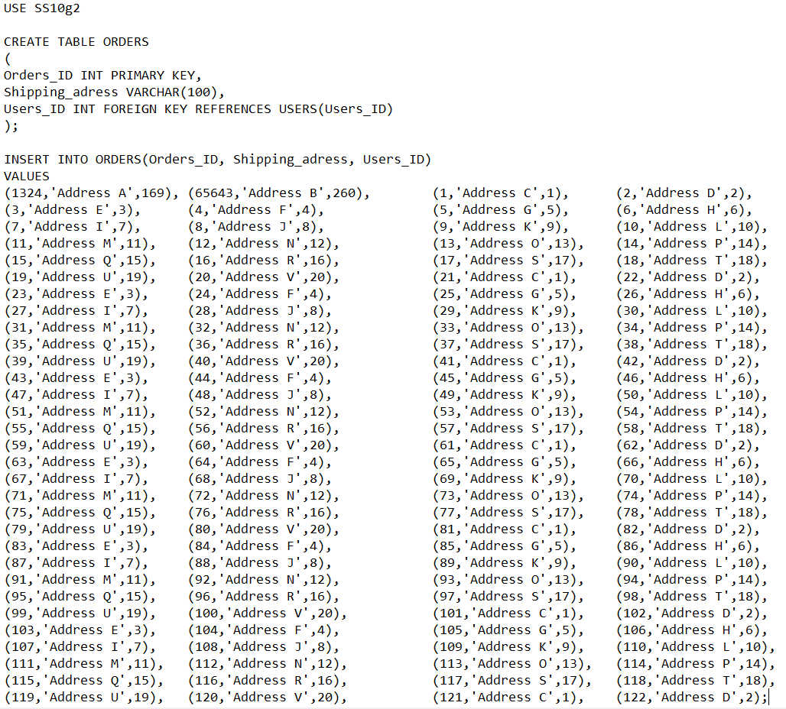

PRODUCTS table:

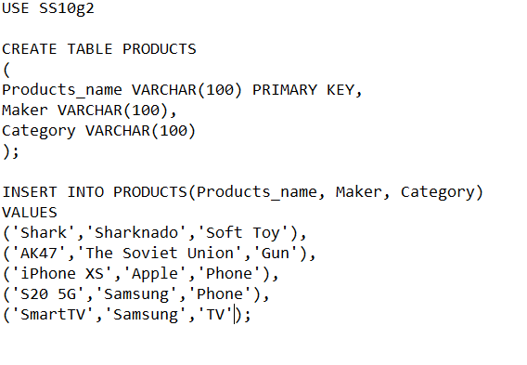

PRODUCTS_IN_ORDER table:

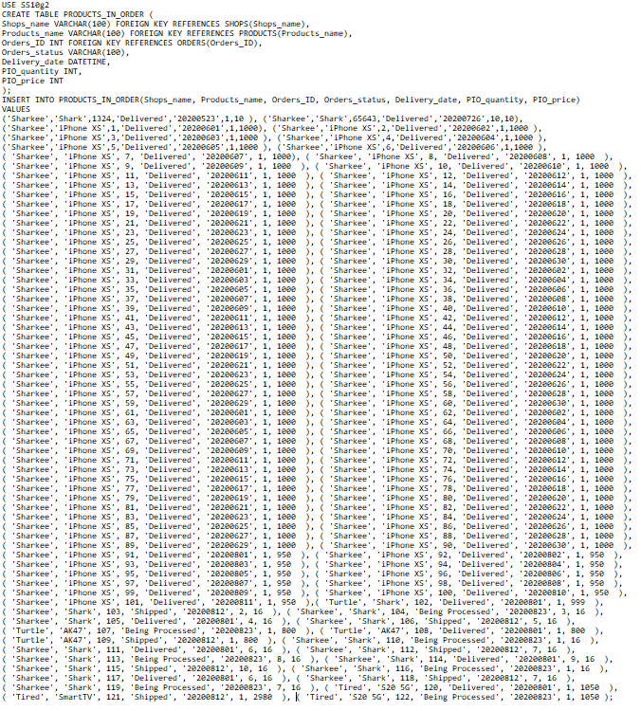

PRODUCTS_IN_SHOPS table:

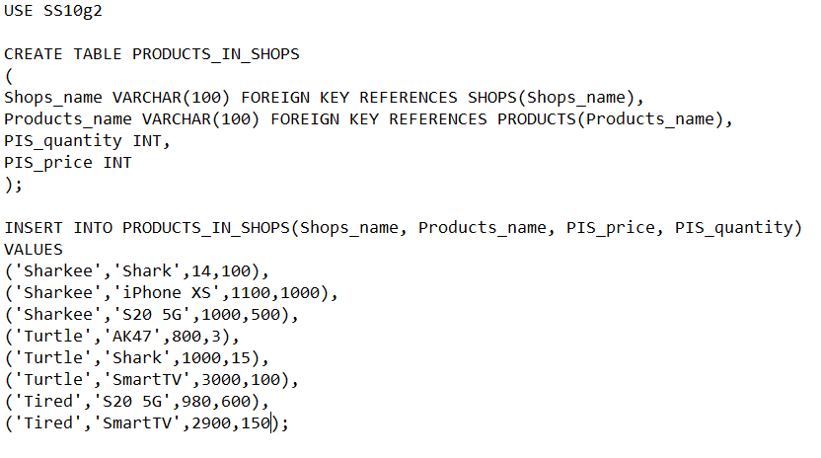

PRICE_HISTORY table:

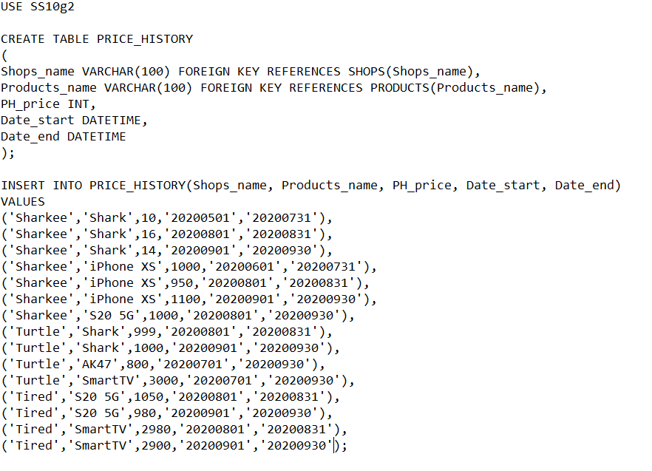

COMPLAINTS_ON_ORDERS:

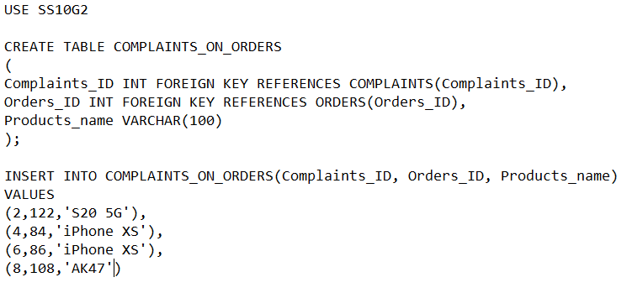

COMPLAINTS_ON_SHOPS table:

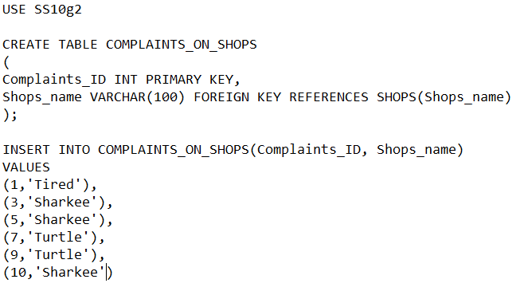

COMPLAINTS table:

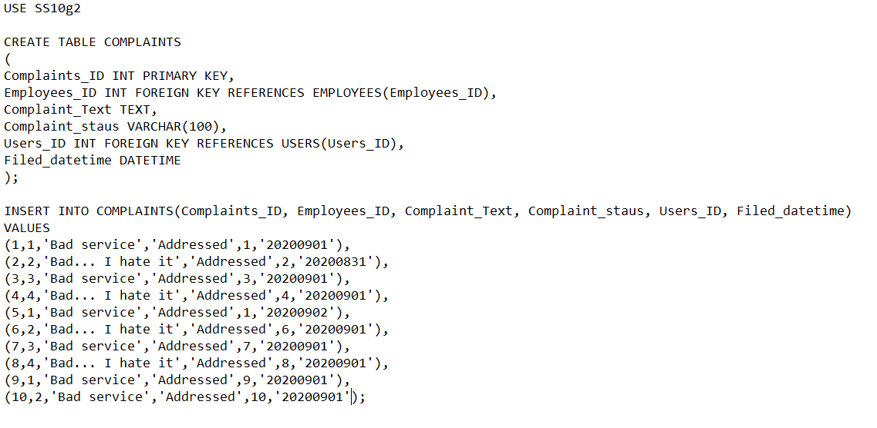

HANDLED table

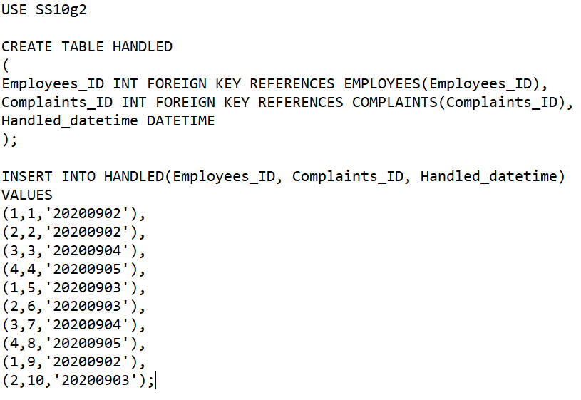

IN_SHOPSNAME_PRODUCTSNAME table:

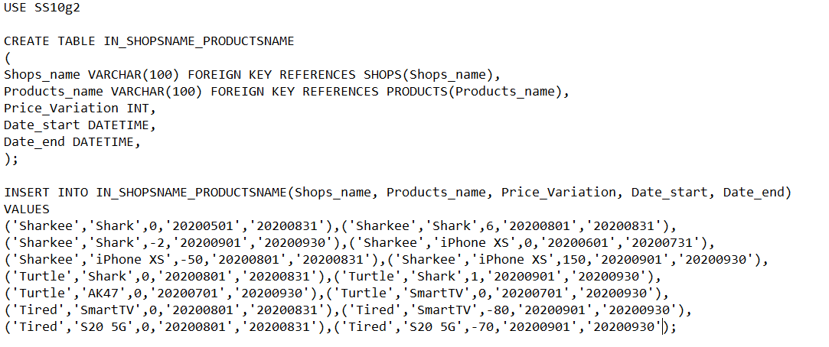

FEEDBACK table:

Users_ID Shops_name Products_name Orders_ID Ratings Comments Filed_datetime

169 Sharkee Shark 1324 5 Great! 2020-10-25 00:00:00.000

169 Turtle Shark 65643 4.5 Not as good as Sharkee 2020-10-27 00:00:00.000

1 Sharkee iPhone XS 1 5 Great! I love it! 2020-08-25 00:00:00.000

2 Sharkee iPhone XS 2 5 Great! I love it! 2020-08-25 00:00:00.000

3 Sharkee iPhone XS 3 5 Great! I love it! 2020-08-25 00:00:00.000

4 Sharkee iPhone XS 4 5 Great! I love it! 2020-08-25 00:00:00.000

5 Sharkee iPhone XS 5 5 Great! I love it! 2020-08-25 00:00:00.000

6 Sharkee iPhone XS 6 5 Great! I love it! 2020-08-25 00:00:00.000

7 Sharkee iPhone XS 7 5 Great! I love it! 2020-08-25 00:00:00.000

8 Sharkee iPhone XS 8 5 Great! I love it! 2020-08-25 00:00:00.000

9 Sharkee iPhone XS 9 5 Great! I love it! 2020-08-25 00:00:00.000

10 Sharkee iPhone XS 10 5 Great! I love it! 2020-08-25 00:00:00.000

11 Sharkee iPhone XS 11 5 Great! I love it! 2020-08-25 00:00:00.000

12 Sharkee iPhone XS 12 5 Great! I love it! 2020-08-25 00:00:00.000

13 Sharkee iPhone XS 13 5 Great! I love it! 2020-08-25 00:00:00.000

14 Sharkee iPhone XS 14 5 Great! I love it! 2020-08-25 00:00:00.000

15 Sharkee iPhone XS 15 5 Great! I love it! 2020-08-25 00:00:00.000

16 Sharkee iPhone XS 16 5 Great! I love it! 2020-08-25 00:00:00.000

17 Sharkee iPhone XS 17 5 Great! I love it! 2020-08-25 00:00:00.000

18 Sharkee iPhone XS 18 5 Great! I love it! 2020-08-25 00:00:00.000

19 Sharkee iPhone XS 19 5 Great! I love it! 2020-08-25 00:00:00.000

20 Sharkee iPhone XS 20 5 Great! I love it! 2020-08-25 00:00:00.000

1 Sharkee iPhone XS 21 5 Great! I love it! 2020-08-25 00:00:00.000

2 Sharkee iPhone XS 22 5 Great! I love it! 2020-08-25 00:00:00.000

3 Sharkee iPhone XS 23 5 Great! I love it! 2020-08-25 00:00:00.000

4 Sharkee iPhone XS 24 5 Great! I love it! 2020-08-25 00:00:00.000

5 Sharkee iPhone XS 25 5 Great! I love it! 2020-08-25 00:00:00.000

6 Sharkee iPhone XS 26 5 Great! I love it! 2020-08-25 00:00:00.000

7 Sharkee iPhone XS 27 5 Great! I love it! 2020-08-25 00:00:00.000

8 Sharkee iPhone XS 28 5 Great! I love it! 2020-08-25 00:00:00.000

9 Sharkee iPhone XS 29 5 Great! I love it! 2020-08-25 00:00:00.000

10 Sharkee iPhone XS 30 5 Great! I love it! 2020-08-25 00:00:00.000

11 Sharkee iPhone XS 31 5 Great! I love it! 2020-08-25 00:00:00.000

12 Sharkee iPhone XS 32 5 Great! I love it! 2020-08-25 00:00:00.000

13 Sharkee iPhone XS 33 5 Great! I love it! 2020-08-25 00:00:00.000

14 Sharkee iPhone XS 34 5 Great! I love it! 2020-08-25 00:00:00.000

15 Sharkee iPhone XS 35 5 Great! I love it! 2020-08-25 00:00:00.000

16 Sharkee iPhone XS 36 5 Great! I love it! 2020-08-25 00:00:00.000

17 Sharkee iPhone XS 37 5 Great! I love it! 2020-08-25 00:00:00.000

18 Sharkee iPhone XS 38 5 Great! I love it! 2020-08-25 00:00:00.000

19 Sharkee iPhone XS 39 5 Great! I love it! 2020-08-25 00:00:00.000

20 Sharkee iPhone XS 40 5 Great! I love it! 2020-08-25 00:00:00.000

1 Sharkee iPhone XS 41 5 Great! I love it! 2020-08-25 00:00:00.000

2 Sharkee iPhone XS 42 5 Great! I love it! 2020-08-25 00:00:00.000

3 Sharkee iPhone XS 43 5 Great! I love it! 2020-08-25 00:00:00.000

4 Sharkee iPhone XS 44 5 Great! I love it! 2020-08-25 00:00:00.000

5 Sharkee iPhone XS 45 5 Great! I love it! 2020-08-25 00:00:00.000

6 Sharkee iPhone XS 46 5 Great! I love it! 2020-08-25 00:00:00.000

7 Sharkee iPhone XS 47 5 Great! I love it! 2020-08-25 00:00:00.000

8 Sharkee iPhone XS 48 5 Great! I love it! 2020-08-25 00:00:00.000

9 Sharkee iPhone XS 49 5 Great! I love it! 2020-08-25 00:00:00.000

10 Sharkee iPhone XS 50 5 Great! I love it! 2020-08-25 00:00:00.000

11 Sharkee iPhone XS 51 5 Great! I love it! 2020-08-25 00:00:00.000

12 Sharkee iPhone XS 52 5 Great! I love it! 2020-08-25 00:00:00.000

13 Sharkee iPhone XS 53 5 Great! I love it! 2020-08-25 00:00:00.000

14 Sharkee iPhone XS 54 5 Great! I love it! 2020-08-25 00:00:00.000

15 Sharkee iPhone XS 55 5 Great! I love it! 2020-08-25 00:00:00.000

16 Sharkee iPhone XS 56 5 Great! I love it! 2020-08-25 00:00:00.000

17 Sharkee iPhone XS 57 5 Great! I love it! 2020-08-25 00:00:00.000

18 Sharkee iPhone XS 58 5 Great! I love it! 2020-08-25 00:00:00.000

19 Sharkee iPhone XS 59 5 Great! I love it! 2020-08-25 00:00:00.000

20 Sharkee iPhone XS 60 5 Great! I love it! 2020-08-25 00:00:00.000

1 Sharkee iPhone XS 61 5 Great! I love it! 2020-08-25 00:00:00.000

2 Sharkee iPhone XS 62 5 Great! I love it! 2020-08-25 00:00:00.000

3 Sharkee iPhone XS 63 5 Great! I love it! 2020-08-25 00:00:00.000

4 Sharkee iPhone XS 64 5 Great! I love it! 2020-08-25 00:00:00.000

5 Sharkee iPhone XS 65 5 Great! I love it! 2020-08-25 00:00:00.000

6 Sharkee iPhone XS 66 5 Great! I love it! 2020-08-25 00:00:00.000

7 Sharkee iPhone XS 67 5 Great! I love it! 2020-08-25 00:00:00.000

8 Sharkee iPhone XS 68 5 Great! I love it! 2020-08-25 00:00:00.000

9 Sharkee iPhone XS 69 5 Great! I love it! 2020-08-25 00:00:00.000

10 Sharkee iPhone XS 70 5 Great! I love it! 2020-08-25 00:00:00.000

11 Sharkee iPhone XS 71 5 Great! I love it! 2020-08-25 00:00:00.000

12 Sharkee iPhone XS 72 5 Great! I love it! 2020-08-25 00:00:00.000

13 Sharkee iPhone XS 73 5 Great! I love it! 2020-08-25 00:00:00.000

14 Sharkee iPhone XS 74 5 Great! I love it! 2020-08-25 00:00:00.000

15 Sharkee iPhone XS 75 5 Great! I love it! 2020-08-25 00:00:00.000

16 Sharkee iPhone XS 76 5 Great! I love it! 2020-08-25 00:00:00.000

17 Sharkee iPhone XS 77 5 Great! I love it! 2020-08-25 00:00:00.000

18 Sharkee iPhone XS 78 5 Great! I love it! 2020-08-25 00:00:00.000

19 Sharkee iPhone XS 79 5 Great! I love it! 2020-08-25 00:00:00.000

20 Sharkee iPhone XS 80 5 Great! I love it! 2020-08-25 00:00:00.000

1 Sharkee iPhone XS 81 5 Great! I love it! 2020-08-25 00:00:00.000

2 Sharkee iPhone XS 82 5 Great! I love it! 2020-08-25 00:00:00.000

3 Sharkee iPhone XS 83 5 Great! I love it! 2020-08-25 00:00:00.000

4 Sharkee iPhone XS 84 5 Great! I love it! 2020-08-25 00:00:00.000

5 Sharkee iPhone XS 85 5 Great! I love it! 2020-08-25 00:00:00.000

6 Sharkee iPhone XS 86 5 Great! I love it! 2020-08-25 00:00:00.000

7 Sharkee iPhone XS 87 5 Great! I love it! 2020-08-25 00:00:00.000

8 Sharkee iPhone XS 88 5 Great! I love it! 2020-08-25 00:00:00.000

9 Sharkee iPhone XS 89 5 Great! I love it! 2020-08-25 00:00:00.000

10 Sharkee iPhone XS 90 5 Great! I love it! 2020-08-25 00:00:00.000

11 Sharkee iPhone XS 91 5 Great! I love it! 2020-08-25 00:00:00.000

12 Sharkee iPhone XS 92 5 Great! I love it! 2020-08-25 00:00:00.000

13 Sharkee iPhone XS 93 5 Great! I love it! 2020-08-25 00:00:00.000

14 Sharkee iPhone XS 94 5 Great! I love it! 2020-08-25 00:00:00.000

15 Sharkee iPhone XS 95 5 Great! I love it! 2020-08-25 00:00:00.000

16 Sharkee iPhone XS 96 5 Great! I love it! 2020-08-25 00:00:00.000

17 Sharkee iPhone XS 97 5 Great! I love it! 2020-08-25 00:00:00.000

18 Sharkee iPhone XS 98 5 Great! I love it! 2020-08-25 00:00:00.000

19 Sharkee iPhone XS 99 5 Great! I love it! 2020-08-25 00:00:00.000

20 Sharkee iPhone XS 100 5 Great! I love it! 2020-08-25 00:00:00.000

1 Sharkee iPhone XS 101 1 I hate it 2020-08-25 00:00:00.000

IN_ORDERID_PRODUCTSNAME Table:

Users_ID Products_name Order_datetime

1324 Shark 2020-05-19 00:00:00.000

65643 Shark 2020-07-25 00:00:00.000

1 iPhone XS 2020-06-01 00:00:00.000

2 iPhone XS 2020-06-01 00:00:00.000

3 iPhone XS 2020-06-01 00:00:00.000

4 iPhone XS 2020-06-01 00:00:00.000

5 iPhone XS 2020-06-01 00:00:00.000

6 iPhone XS 2020-06-01 00:00:00.000

7 iPhone XS 2020-06-01 00:00:00.000

8 iPhone XS 2020-06-01 00:00:00.000

9 iPhone XS 2020-06-01 00:00:00.000

10 iPhone XS 2020-06-10 00:00:00.000

11 iPhone XS 2020-06-10 00:00:00.000

12 iPhone XS 2020-06-10 00:00:00.000

13 iPhone XS 2020-06-10 00:00:00.000

14 iPhone XS 2020-06-10 00:00:00.000

15 iPhone XS 2020-06-10 00:00:00.000

16 iPhone XS 2020-06-10 00:00:00.000

17 iPhone XS 2020-06-10 00:00:00.000

18 iPhone XS 2020-06-10 00:00:00.000

19 iPhone XS 2020-06-10 00:00:00.000

20 iPhone XS 2020-06-20 00:00:00.000

21 iPhone XS 2020-06-20 00:00:00.000

22 iPhone XS 2020-06-20 00:00:00.000

23 iPhone XS 2020-06-20 00:00:00.000

24 iPhone XS 2020-06-20 00:00:00.000

25 iPhone XS 2020-06-20 00:00:00.000

26 iPhone XS 2020-06-20 00:00:00.000

27 iPhone XS 2020-06-20 00:00:00.000

28 iPhone XS 2020-06-20 00:00:00.000

29 iPhone XS 2020-06-20 00:00:00.000

30 iPhone XS 2020-06-20 00:00:00.000

31 iPhone XS 2020-06-01 00:00:00.000

32 iPhone XS 2020-06-01 00:00:00.000

33 iPhone XS 2020-06-01 00:00:00.000

34 iPhone XS 2020-06-01 00:00:00.000

35 iPhone XS 2020-06-01 00:00:00.000

36 iPhone XS 2020-06-01 00:00:00.000

37 iPhone XS 2020-06-01 00:00:00.000

38 iPhone XS 2020-06-01 00:00:00.000

39 iPhone XS 2020-06-01 00:00:00.000

40 iPhone XS 2020-06-10 00:00:00.000

41 iPhone XS 2020-06-10 00:00:00.000

42 iPhone XS 2020-06-10 00:00:00.000

43 iPhone XS 2020-06-10 00:00:00.000

44 iPhone XS 2020-06-10 00:00:00.000

45 iPhone XS 2020-06-10 00:00:00.000

46 iPhone XS 2020-06-10 00:00:00.000

47 iPhone XS 2020-06-10 00:00:00.000

48 iPhone XS 2020-06-10 00:00:00.000

49 iPhone XS 2020-06-10 00:00:00.000

50 iPhone XS 2020-06-20 00:00:00.000

51 iPhone XS 2020-06-20 00:00:00.000

52 iPhone XS 2020-06-20 00:00:00.000

53 iPhone XS 2020-06-20 00:00:00.000

54 iPhone XS 2020-06-20 00:00:00.000

55 iPhone XS 2020-06-20 00:00:00.000

56 iPhone XS 2020-06-20 00:00:00.000

57 iPhone XS 2020-06-20 00:00:00.000

58 iPhone XS 2020-06-20 00:00:00.000

59 iPhone XS 2020-06-20 00:00:00.000

60 iPhone XS 2020-06-20 00:00:00.000

61 iPhone XS 2020-06-01 00:00:00.000

62 iPhone XS 2020-06-01 00:00:00.000

63 iPhone XS 2020-06-01 00:00:00.000

64 iPhone XS 2020-06-01 00:00:00.000

65 iPhone XS 2020-06-01 00:00:00.000

66 iPhone XS 2020-06-01 00:00:00.000

67 iPhone XS 2020-06-01 00:00:00.000

68 iPhone XS 2020-06-01 00:00:00.000

69 iPhone XS 2020-06-01 00:00:00.000

70 iPhone XS 2020-06-10 00:00:00.000

71 iPhone XS 2020-06-10 00:00:00.000

72 iPhone XS 2020-06-10 00:00:00.000

73 iPhone XS 2020-06-10 00:00:00.000

74 iPhone XS 2020-06-10 00:00:00.000

75 iPhone XS 2020-06-10 00:00:00.000

76 iPhone XS 2020-06-10 00:00:00.000

77 iPhone XS 2020-06-10 00:00:00.000

78 iPhone XS 2020-06-10 00:00:00.000

79 iPhone XS 2020-06-10 00:00:00.000

80 iPhone XS 2020-06-20 00:00:00.000

81 iPhone XS 2020-06-20 00:00:00.000

82 iPhone XS 2020-06-20 00:00:00.000

83 iPhone XS 2020-06-20 00:00:00.000

84 iPhone XS 2020-06-20 00:00:00.000

85 iPhone XS 2020-06-20 00:00:00.000

86 iPhone XS 2020-06-20 00:00:00.000

87 iPhone XS 2020-06-20 00:00:00.000

88 iPhone XS 2020-06-20 00:00:00.000

89 iPhone XS 2020-06-20 00:00:00.000

90 iPhone XS 2020-06-20 00:00:00.000

91 iPhone XS 2020-08-01 00:00:00.000

92 iPhone XS 2020-08-01 00:00:00.000

93 iPhone XS 2020-08-01 00:00:00.000

94 iPhone XS 2020-08-01 00:00:00.000

95 iPhone XS 2020-08-01 00:00:00.000

96 iPhone XS 2020-08-01 00:00:00.000

97 iPhone XS 2020-08-01 00:00:00.000

98 iPhone XS 2020-08-01 00:00:00.000

99 iPhone XS 2020-08-01 00:00:00.000

100 iPhone XS 2020-08-01 00:00:00.000

101 iPhone XS 2020-08-01 00:00:00.000

102 Shark 2020-08-01 00:00:00.000

103 Shark 2020-08-11 00:00:00.000

104 Shark 2020-08-20 00:00:00.000

105 Shark 2020-08-01 00:00:00.000

106 Shark 2020-08-11 00:00:00.000

107 AK47 2020-08-20 00:00:00.000

108 AK47 2020-08-01 00:00:00.000

109 AK47 2020-08-11 00:00:00.000

110 Shark 2020-08-20 00:00:00.000

111 Shark 2020-08-01 00:00:00.000

112 Shark 2020-08-11 00:00:00.000

113 Shark 2020-08-20 00:00:00.000

114 Shark 2020-08-01 00:00:00.000

115 Shark 2020-08-11 00:00:00.000

116 Shark 2020-08-20 00:00:00.000

117 Shark 2020-08-01 00:00:00.000

118 Shark 2020-08-11 00:00:00.000

119 Shark 2020-08-20 00:00:00.000

120 S20 5G 2020-08-01 00:00:00.000

121 SmartTV 2020-08-11 00:00:00.000

122 S20 5G 2020-08-20 00:00:00.000

123 Shark 2020-06-01 00:00:00.000

124 Shark 2020-07-01 00:00:00.000

125 Shark 2020-07-01 00:00:00.000

126 Shark 2020-08-01 00:00:00.000

127 Shark 2020-08-01 00:00:00.000

128 Shark 2020-08-01 00:00:00.000

123 Shark 2020-08-20 00:00:00.000

124 S20 5G 2020-08-01 00:00:00.000

125 SmartTV 2020-08-11 00:00:00.000

126 S20 5G 2020-08-20 00:00:00.000

**1. Find the average price of “iPhone Xs” on Sharkee from 1 August 2020 to 31 August 2020.**

USE SS10g2

SELECT AVG(PH_price) AS "Average Price"

FROM PRICE_HISTORY

WHERE Products_name = 'iPhone XS'

AND

(Date_start >= '2020-08-01 00:00:00' AND Date_start <= '2020-08-31 23:59:59')

AND

(Date_end >= '2020-08-01 00:00:00' AND Date_end <= '2020-08-31 23:59:59');

TABLE:



RESULTS:



**2. Find products that received at least 100 ratings of “5” in August 2020, and order them by their average ratings.**

Assume that the total number of products is calculated from all the shops in sharkee

(Search product, search will comeback with the products from all the shops)

USE SS10g2;

WITH moreThan100_5StarRating AS

(

SELECT Products_name, Rating

FROM Feedback

WHERE Rating = 5

AND DATEPART(month, Feedback_datetime) = 8

AND DATEPART(year, Feedback_datetime) = 2020

GROUP BY Products_name, Rating

HAVING COUNT(Rating) >= 100

)

SELECT f.Products_name, AVG(CAST(f.Rating AS FLOAT)) as 'Average Ratings'

FROM Feedback f, moreThan100_5StarRating MTSR

WHERE f.Products_name = MTSR.Products_name

AND DATEPART(month, Feedback_datetime) = 8

AND DATEPART(year, Feedback_datetime) = 2020 //select the date

GROUP BY f.Products_name ORDER BY AVG(f.Rating) ASC;

TABLE:

(There are 98 more ratings of 5 that we are not able to display due to the lack of space)

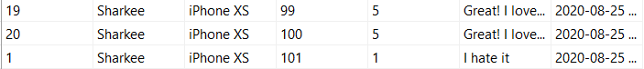

CALCULATION:

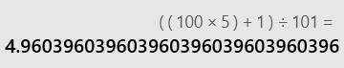

RESULTS:



**3. For all products purchased in June 2020 that have been delivered, find the average time from the ordering date to the delivery date.**

USE SS10g2;

--create a view to obtain the products that have been delivered

-- then use a where condition to obtain the june condition

-- proceed to select the avg of the date difference between the date ordered and the delivery date.

WITH june(Products_name,Order_datetime,Delivery_date) AS(

SELECT I.Products_name,I.Order_datetime,PIO.Delivery_date

FROM IN_ORDERID_PRODUCTSNAME AS I,PRODUCTS_IN_ORDER AS PIO

WHERE I.Orders_ID=PIO.Orders_ID AND PIO.Orders_status='Delivered'

GROUP BY I.Products_name,I.Order_datetime,PIO.Delivery_date)

SELECT j.Products_name,AVG(Datediff(day,j.Order_datetime,j.Delivery_date)) AS avgTime

FROM june AS j

WHERE j.Order_datetime>= '2020-06-01 00:00:00' AND j.Order_datetime<= '2020-06-30 23:59:59'

GROUP BY j.Products_name;

RESULTS:

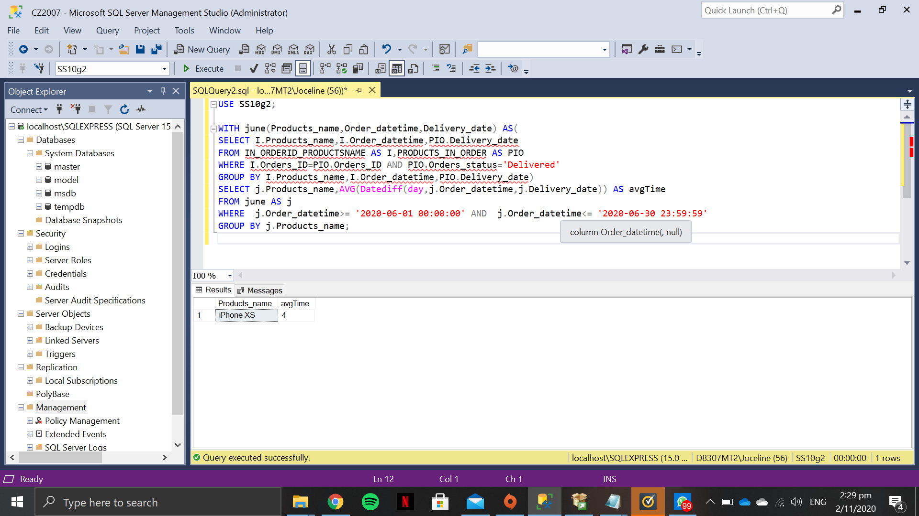

**4. Let us define the “latency” of an employee by the average that he/she takes to process a complaint. Find the employee with the smallest latency.**

USE SS10g2;

--Calculate the difference in days via datediff and find the avg

--group by the employees_ID

--Select the min from the view to obtain smallest latency

WITH Latency(Employees_ID,AvgLatency)

AS

(

SELECT C.Employees_ID, AVG(Datediff(DAY, C.Filed_datetime, H.Handled_datetime))

FROM COMPLAINTS AS C, HANDLED AS H

WHERE C.Employees_ID = H.Employees_ID

GROUP BY C.Employees_ID

)

SELECT L.Employees_ID

FROM latency AS L

WHERE L.AvgLatency =(SELECT MIN(AvgLatency)

FROM latency);

RESULTS:

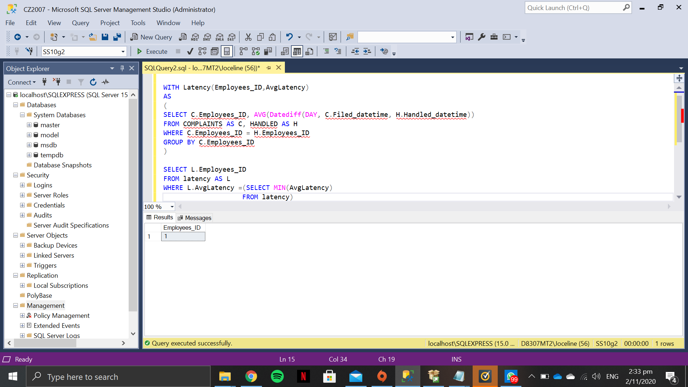

**5. Produce a list that contains (i) all products made by Samsung, and (ii) for each of them, the number of shops on Sharkee that sell the product.**

(i)

USE SS10g2;

SELECT Products_name

FROM PRODUCTS

WHERE Maker = 'Samsung'

(ii)

USE SS10g2;

SELECT PRODUCTS.Products_name, COUNT(Shops_name) as 'Number Of Shops'

FROM PRODUCTS_IN_SHOPS PIS

RIGHT JOIN PRODUCTS ON PIS.Products_name = PRODUCTS.Products_name

WHERE Maker = 'Samsung'

GROUP BY PRODUCTS.Products_name;

RESULTS:

(i)

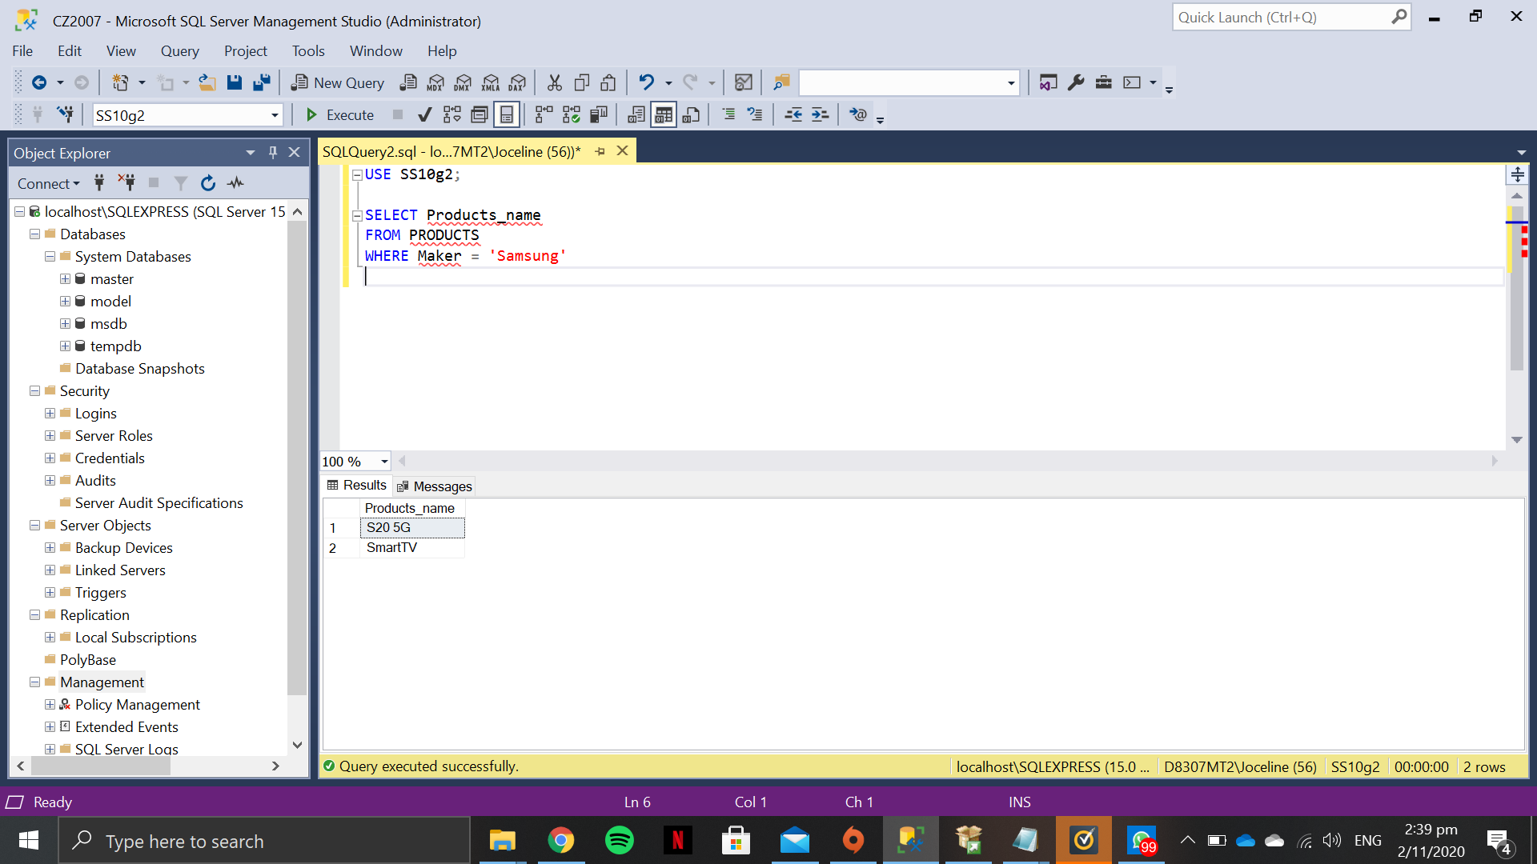

(ii)

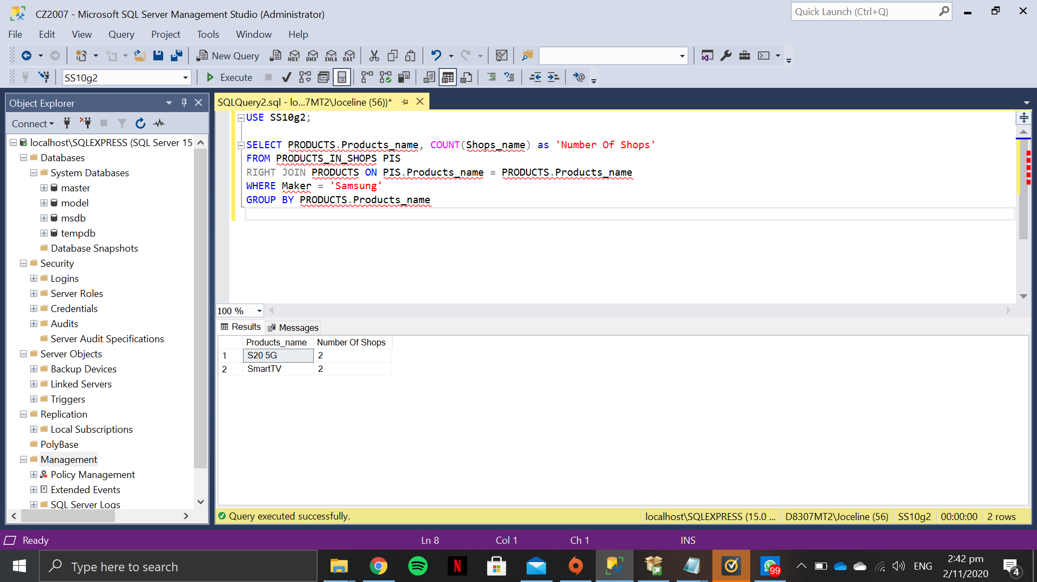

**6. Find top 5 shops that made the most revenue in August 2020. (with revenue earned and top selling product)**

USE SS10g2

SELECT TOP 1 WITH TIES SUM(PIO.PIO_price) as FinalPrice, PIO.Shops_name

FROM PRODUCTS_IN_ORDER AS PIO

JOIN IN_ORDERID_PRODUCTSNAME AS IOP ON IOP.Orders_ID = PIO.Orders_ID

WHERE (IOP.Order_datetime >= '2020-08-01 00:00:00' AND IOP.Order_datetime <= '2020-08-31 23:59:59')

AND PIO.Orders_status <> 'Returned'

GROUP BY PIO.Shops_name

ORDER BY FinalPrice DESC;

RESULTS:

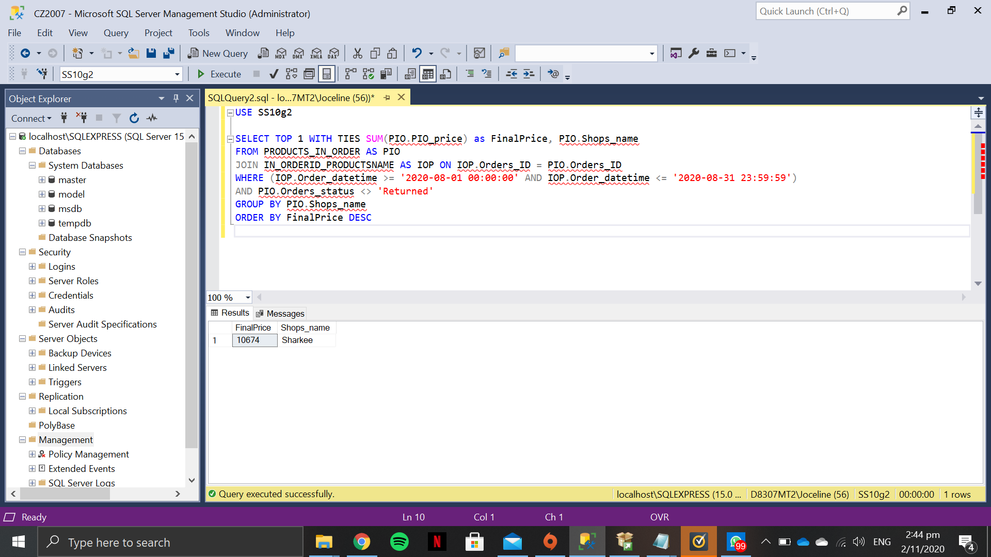

**7. For users that made the most amount of complaints, find the most expensive products he/she has ever purchased.**

USE SS10g2

SELECT PIO.Products_name AS 'Product Name', PIO.PIO_price AS 'Price', O.Users_ID AS 'User ID'

FROM PRODUCTS_IN_ORDER as PIO

JOIN ORDERS O ON PIO.Orders_ID = O.Orders_ID

JOIN (

SELECT MAX(PIO.PIO_price) AS 'Price', O.Users_ID

FROM ORDERS O

LEFT JOIN PRODUCTS_IN_ORDER PIO ON O.Orders_ID = PIO.Orders_ID

WHERE O.Users_ID IN (

SELECT TOP 1 WITH TIES C.Users_ID

FROM COMPLAINTS C

GROUP BY C.Users_ID

ORDER BY Count(C.Complaints_ID) DESC)

GROUP BY O.Users_ID

) AS mostComplaints ON mostComplaints.Users_ID = O.Users_ID AND (PIO.PIO_price) = mostComplaints.Price;

RESULTS:



**8. Find products that have never been purchased by some users, but are the top 5 most purchased products by other users in August 2020.**

CREATE VIEW AllProducts17 AS(

SELECT Products_name, SUM(PIO_quantity) AS TotalQty

FROM PRODUCTS_IN_ORDER

GROUP BY Products_name);

GO

CREATE VIEW NotTop1Products17 AS(

SELECT *

FROM AllProducts17 AP

WHERE AP.TotalQty <> (SELECT MAX(TotalQty)

FROM AllProducts17 AP2));

GO

CREATE VIEW NotTop2Products17 AS(

SELECT *

FROM NotTop1Products17 NT

WHERE NT.TotalQty <> (SELECT MAX(TotalQty)

FROM NotTop1Products17 NT1));

GO

CREATE VIEW NotTop3Products17 AS(

SELECT *

FROM NotTop2Products17 NT

WHERE NT.TotalQty <> (SELECT MAX(TotalQty)

FROM NotTop2Products17 NT1));

GO

CREATE VIEW NotTop4Products17 AS(

SELECT *

FROM NotTop3Products17 NT

WHERE NT.TotalQty <> (SELECT MAX(TotalQty)

FROM NotTop3Products17 NT1));

GO

CREATE VIEW NotTop5Products17 AS(

SELECT *

FROM NotTop4Products17 NT

WHERE NT.TotalQty <> (SELECT MAX(TotalQty)

FROM NotTop4Products17 NT1));

GO

CREATE VIEW TopProducts17 AS(

SELECT *

FROM AllProducts17

EXCEPT

SELECT *

FROM NotTop5Products17);

GO

CREATE VIEW UserCount17 AS

SELECT COUNT(*) AS NumUniqueUsers

FROM USERS;

GO

CREATE VIEW UniquePurchases17 AS

SELECT Products_name, COUNT(Users_ID) AS NumUniquePurchases

FROM (SELECT DISTINCT U.Users_ID, Products_name

FROM Users U, Orders O, PRODUCTS_IN_ORDER PIO

WHERE U.Users_ID = O.Orders_ID AND O.Orders_ID = PIO.Orders_ID) AS UniquePurchase

GROUP BY Products_name;

GO

SELECT TP.Products_name

FROM TopProducts17 TP, UserCount17 UC, UniquePurchases17 UP

WHERE TP.Products_name = UP.Products_name AND NumUniquePurchases < NumUniqueUsers;

RESULTS:

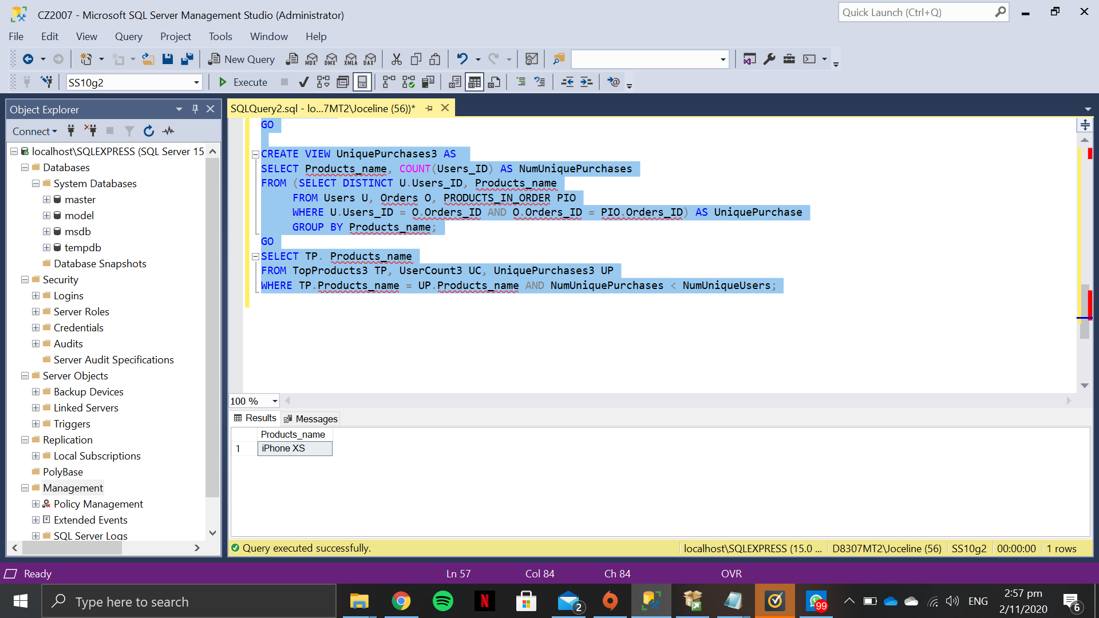

**9. Find products that are increasingly being purchased over at least 3 months**

--comparison done to be done by sales(which consider to be count(order_ID)) per month

--create view for per month

--Comparison with previous months with month-1 and previous month-2

WITH perMonth AS

(SELECT Products_name,MONTH(I.Order_datetime)AS monthNUM,COUNT(Orders_ID) AS sales

FROM IN_ORDERID_PRODUCTSNAME AS I

GROUP BY I.Products_name, MONTH(I.Order_datetime))

SELECT DISTINCT Products_Name

FROM perMonth AS PM

WHERE PM.sales>SOME(SELECT sales

FROM perMonth

WHERE monthNUM = PM.monthNUM -1 AND PM.Products_name = perMonth.Products_name)

AND PM.sales>SOME(SELECT sales

FROM perMonth

WHERE monthNUM = PM.monthNUM -2 AND PM.Products_name = perMonth.Products_name);

RESULTS:



**EXTRA QUERIES**

1. **FIND THE TOP 5 USERS WITH MOST COMPLAINTS, THEN HOW MANY PRODUCTS THEY BOUGHT AND HOW MANY PRODUCTS THEY BOUGHT THAT THEY DIDN’T COMPLAIN ABOUT.**
2. **FIND THE PRODUCTS AND MONTHS WHERE THE PRODUCTS ARE INCREASINGLY PURCHASE ACROSS ANY 3 MONTHS.**

WITH

perMonth AS

(SELECT Products_name,MONTH(I.Order_datetime)AS monthNUM,COUNT(Orders_ID) AS sales

FROM IN_ORDERID_PRODUCTSNAME AS I

GROUP BY I.Products_name, MONTH(I.Order_datetime))

SELECT DISTINCT Products_Name,monthNUM

FROM perMonth AS PM

WHERE PM.sales>SOME(SELECT sales

FROM perMonth

WHERE monthNUM = PM.monthNUM -1 AND PM.Products_name = perMonth.Products_name)

OR PM.sales>SOME(SELECT sales

FROM perMonth

WHERE monthNUM = PM.monthNUM -2 AND PM.Products_name = perMonth.Products_name)

OR PM.sales>SOME(SELECT sales

FROM perMonth

WHERE monthNUM = PM.monthNUM -3 AND PM.Products_name = perMonth.Products_name)

OR PM.sales>SOME(SELECT sales

FROM perMonth

WHERE monthNUM = PM.monthNUM -4 AND PM.Products_name = perMonth.Products_name)

OR PM.sales>SOME(SELECT sales

FROM perMonth

WHERE monthNUM = PM.monthNUM -5 AND PM.Products_name = perMonth.Products_name)

OR PM.sales>SOME(SELECT sales

FROM perMonth

WHERE monthNUM = PM.monthNUM -6 AND PM.Products_name = perMonth.Products_name)

OR PM.sales>SOME(SELECT sales

FROM perMonth

WHERE monthNUM = PM.monthNUM -7 AND PM.Products_name = perMonth.Products_name)

OR PM.sales>SOME(SELECT sales

FROM perMonth

WHERE monthNUM = PM.monthNUM -8 AND PM.Products_name = perMonth.Products_name)

OR PM.sales>SOME(SELECT sales

FROM perMonth

WHERE monthNUM = PM.monthNUM -9 AND PM.Products_name = perMonth.Products_name)

OR PM.sales>SOME(SELECT sales

FROM perMonth

WHERE monthNUM = PM.monthNUM -10 AND PM.Products_name = perMonth.Products_name)

OR PM.sales>SOME(SELECT sales

FROM perMonth

WHERE monthNUM = PM.monthNUM -11 AND PM.Products_name = perMonth.Products_name)

GROUP BY Products_Name,monthNUM

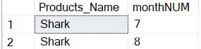

1. **FIND THE REPEATING CUSTOMERS PRINTING OUT THE PRODUCT NAMES, USER ID AND NUMBER OF REPEAT.**

SELECT U.Users_ID, COUNT(*) AS NoOfRepeats, PIO.Products_name

FROM USERS U, PRODUCTS_IN_ORDER PIO, ORDERS O

WHERE O.Users_ID = U.Users_ID AND O.Orders_ID = PIO.Orders_ID

GROUP BY U.Users_ID, Products_name

HAVING COUNT(*)>1;

